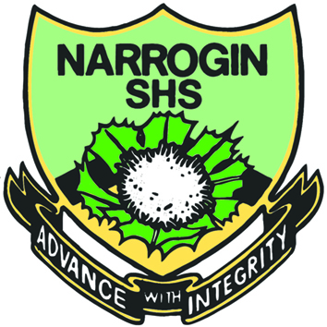
My Target: ____ / or ______ %

Total marks  /70 | % | Weight  10%

Name: _________________ Teacher _______________

Year 7: Aboriginal Culture and Language
Assessment 1, Semester 1: Photo Essay
Photo-Eassy: “An account of a topic told predominantly through photographs with accompanying text.”
Select ONE topic from the following options:
- Hunting and Weapons
- The Arts – dance, paintings, cave art, body decoration
- Traditional groups – territories, languages, clan locations
- Aboriginal Seasons
- Roles of Men, Women and children
Bibliography – must acknowledge all pictures and text
Marking Key.
Criteria | 1 | 2 | 3 | 4 | 5 | 6 | 7 | 8 | 9 | 10
8-10 pages

Theme followed on each page

Image on each page

Writing on each page

Spelling and punctuation is correct

Bibliography

Presentation of Photo-Eassy

Comment:

